Computer Organization & Assembly Language

BS (CS) Fall 2024

Lab 06 Manual


Learning Objectives:

- Recap of Flag Register, Jump instruction (JMP) and Loops

Lab 06

Flag Register:
These registers are used to store information about the state of the processor and the outcomes of various operations. Flag registers contain individual bits, each representing a specific condition or status of the CPU.
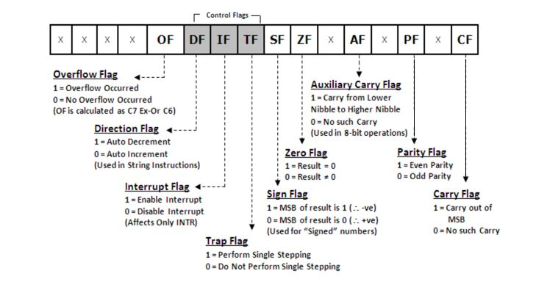

There are two types of flags
- Status flags
- Control flags
Status Flags:
- Allow the results of one instruction to influence later instructions.
- The arithmetic instructions use OF, SF, ZF, AF, PF, and CF
- Carry flag: Carry flag is set if carry is generated for unsigned integers.
- Overflow flag: Overflow flag is set if overflow is generated for signed integers.
- Zero flag: Zero flag is set if a zero is produced, as a result or as a comparison of two integers.
- Sign flag: Sign flag is set to one if the MSB of the destination operand is 1.

Controls flags:
These control flags serve specific purposes in controlling the operation of the CPU. Control flags in a CPU are essential for managing program execution, controlling interrupts, making decisions based on conditions, handling errors.
- Trap Flag (TF): When TF is set, the CPU enters single-step mode, where it executes one instruction at a time and generates a trap interrupt (interrupt 1) after each instruction.
- Interrupt Flag (IF): When IF is set, the CPU allows mask able interrupts to be processed. When it's cleared, mask able interrupts are disabled, preventing the CPU from responding to external interrupt requests.
- Directional Flag (DF):It control the direction of data movement in string operations. When DF is set, data moves from higher memory addresses to lower ones, and vice versa.

Jump Instruction:
JMP is an unconditional jump command that is use to jump to a specific line. That line or block of code is identified by a label. Label can be any word other than the names of the variable used in the code or the keywords.

e.g., START:
mov al,05
JMP START

Loops:
The keyword ‘loop’ runs a static loop of specific number of times and that number is stored in the Counter register, CX.

e.g., mov cx,5
mov al,0
start:
inc al
loop start

Tasks

- Write an assembly language program
    - To add two unsigned numbers and observe which flags are changed

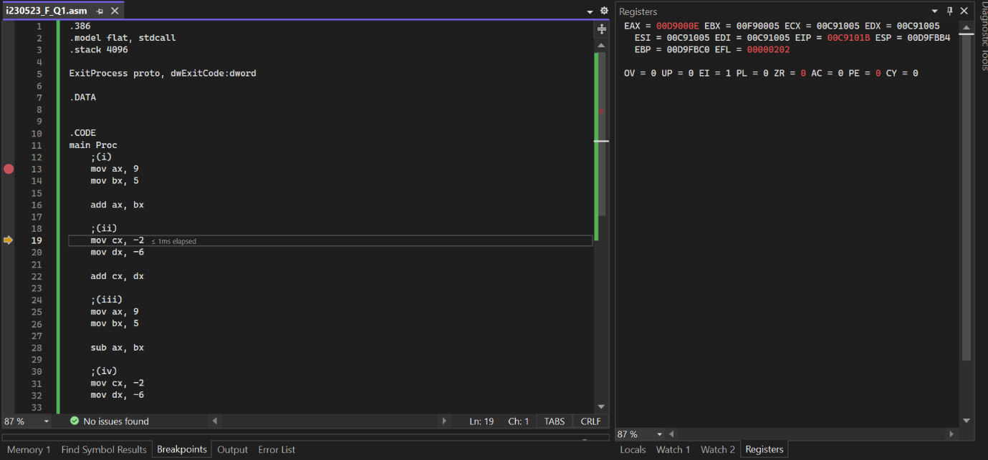

    - To add two signed numbers and observe which flags are changed
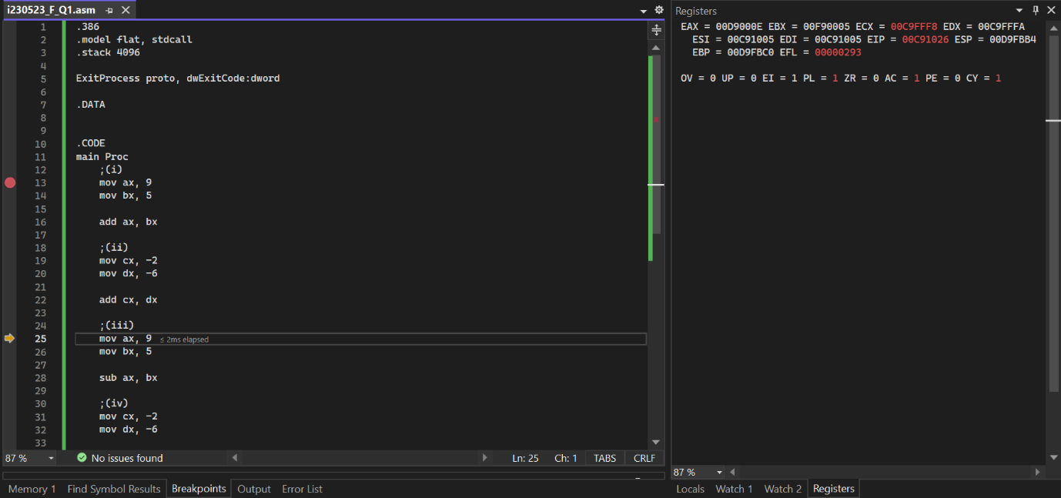

    - To subtract two unsigned numbers and observe which flags are changed
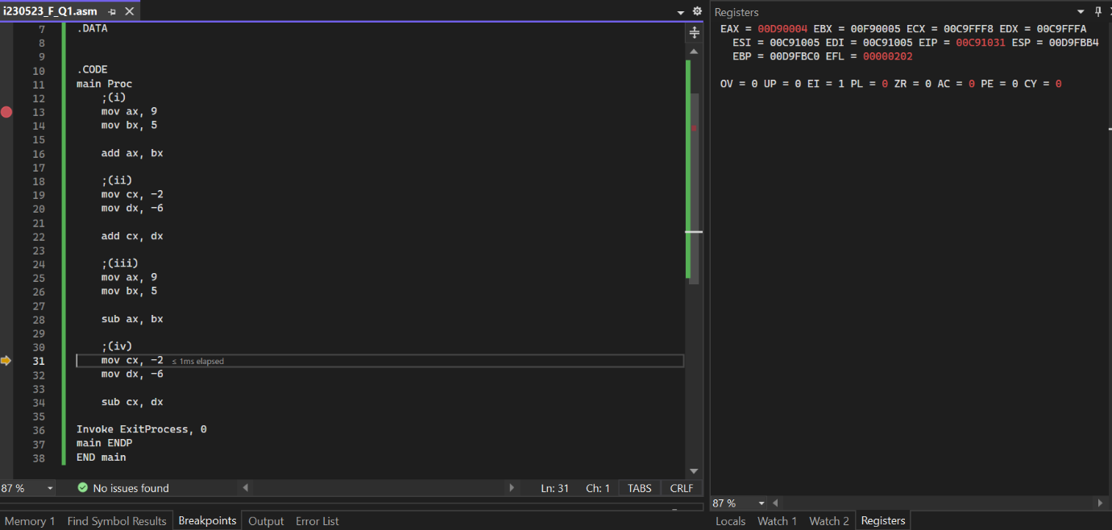

    - To subtract two signed numbers and observe which flags are changed
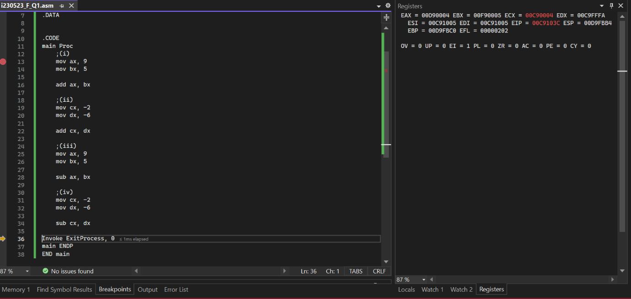

- Write an assembly language program
    - To multiply two unsigned numbers and observe which flags are changed
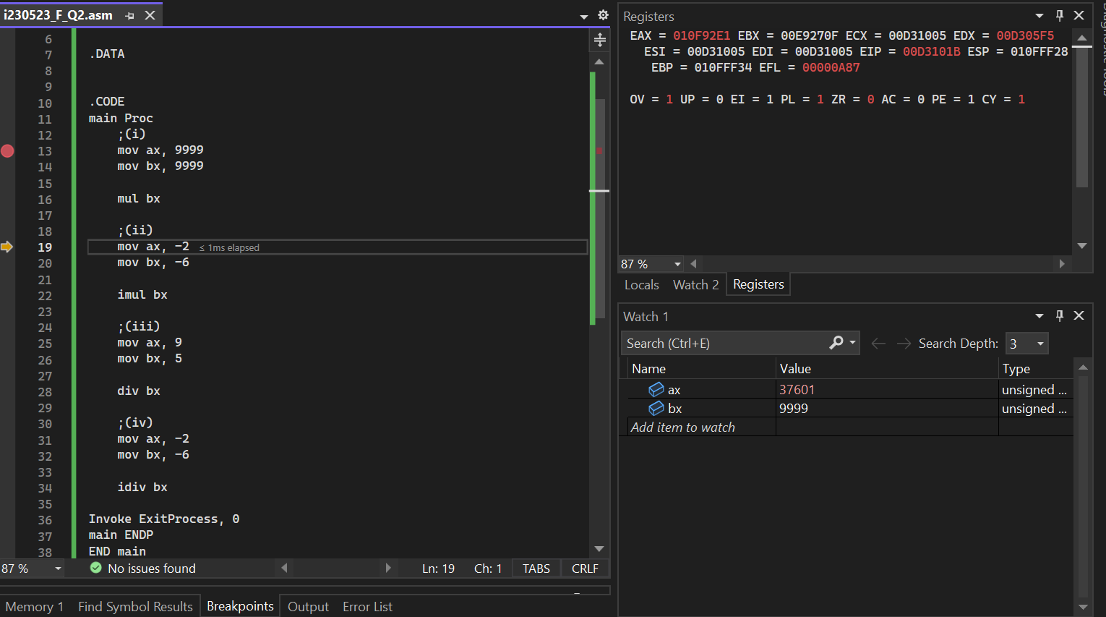
    - To multiply two signed numbers and observe which flags are changed
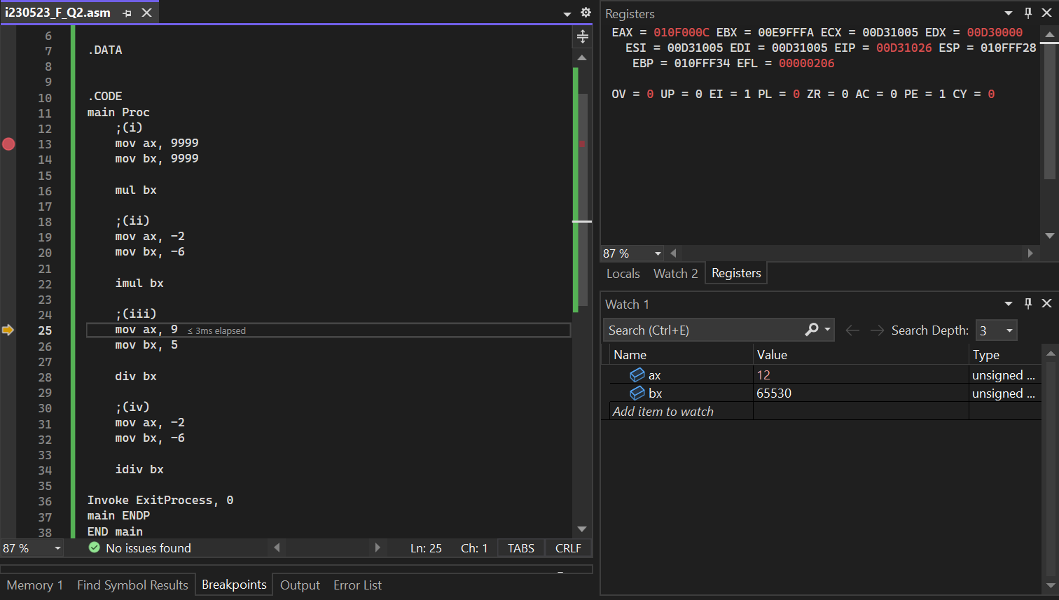
    - To divide two unsigned numbers and observe which flags are changed
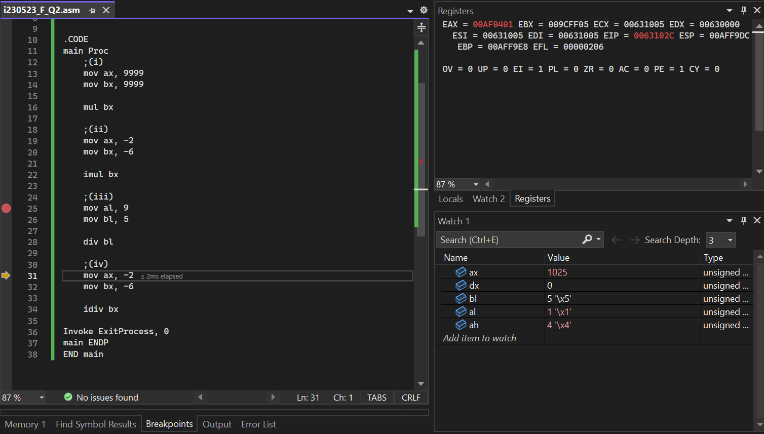
    - To divide two signed numbers and observe which flags are changed

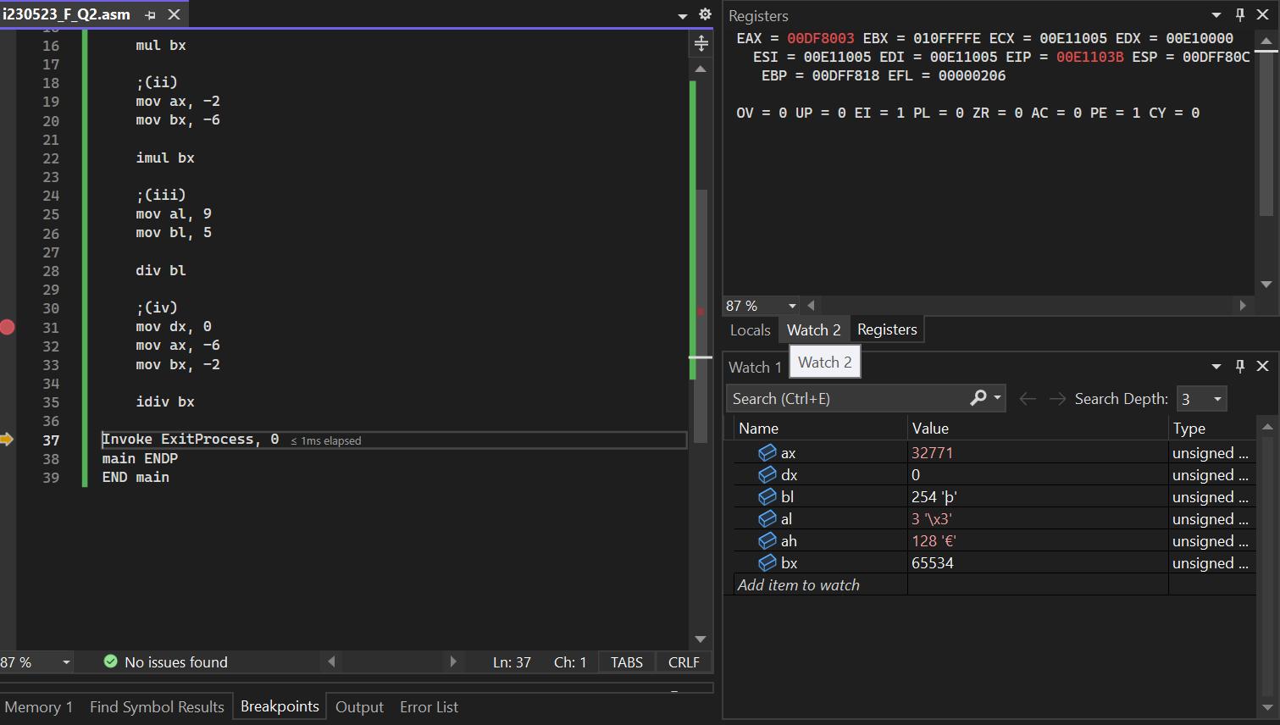

- Write an assembly language program to reverse an array using loop and indirect addressing.
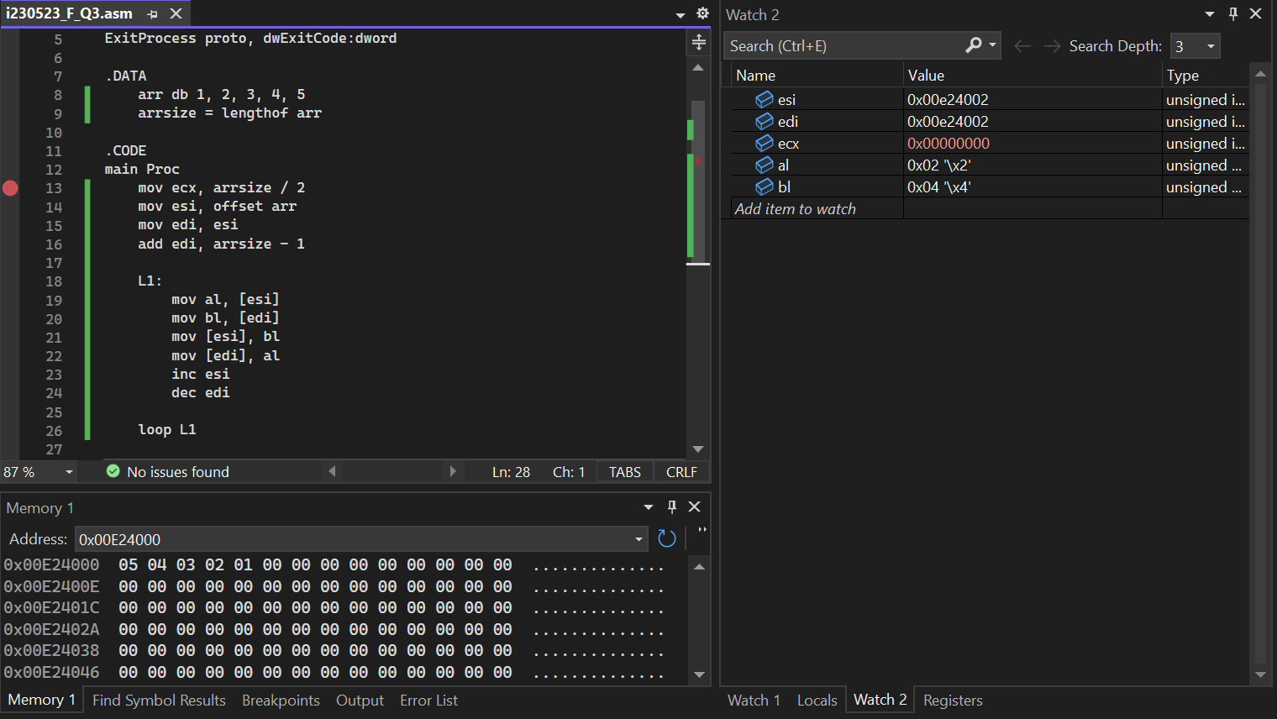

- Write an assembly language program to create an array of 5 elements, then take the square of each element of the array.
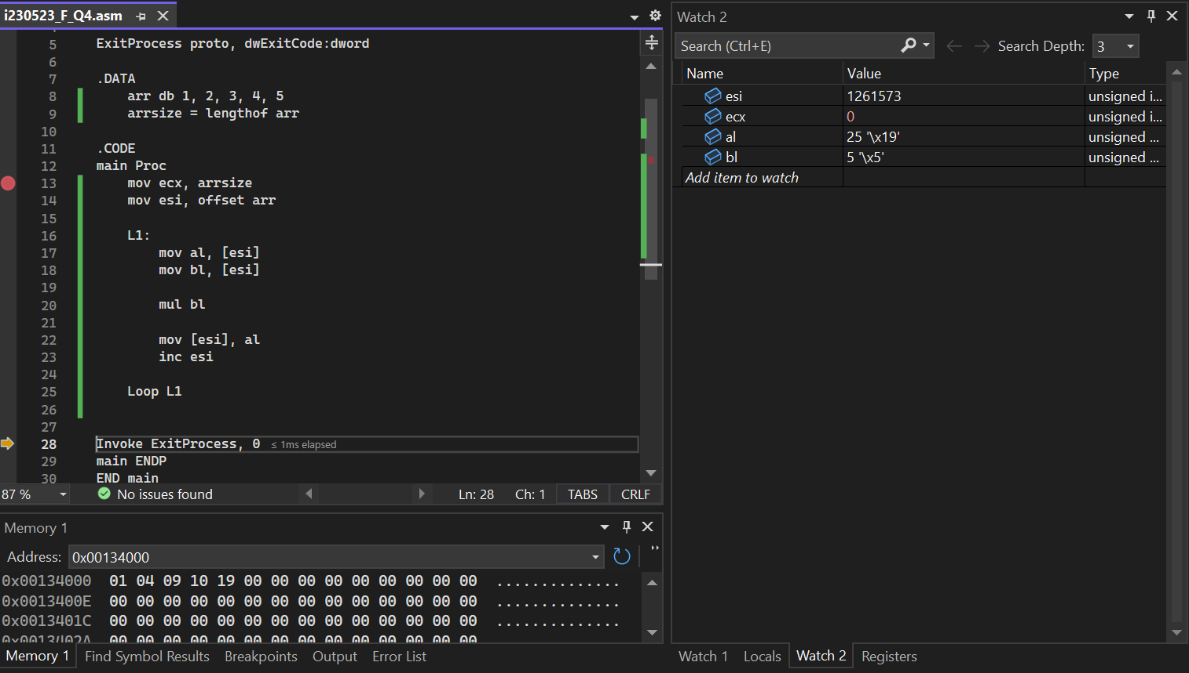
- Consider two binary numbers, A = 1011 and B = 1101. Perform addition, subtraction, Multiplication, division operation. Provide the binary result along with flags value. Explain why flags is set or not set.
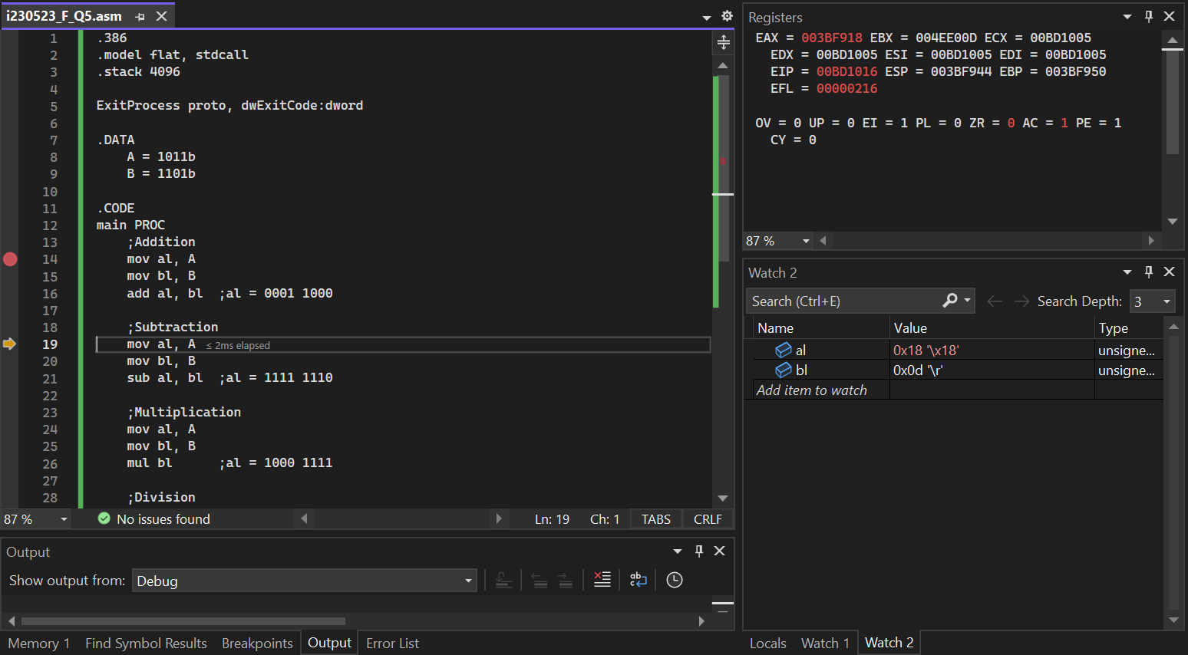
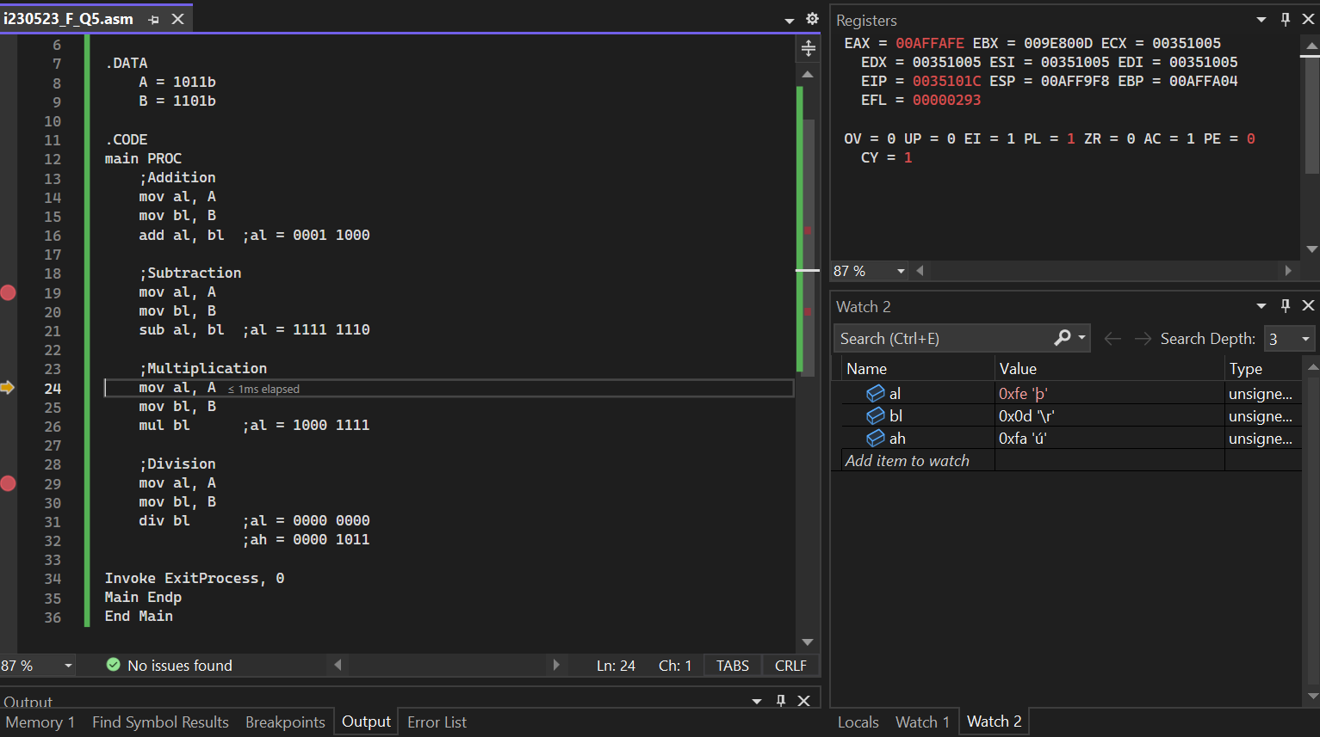
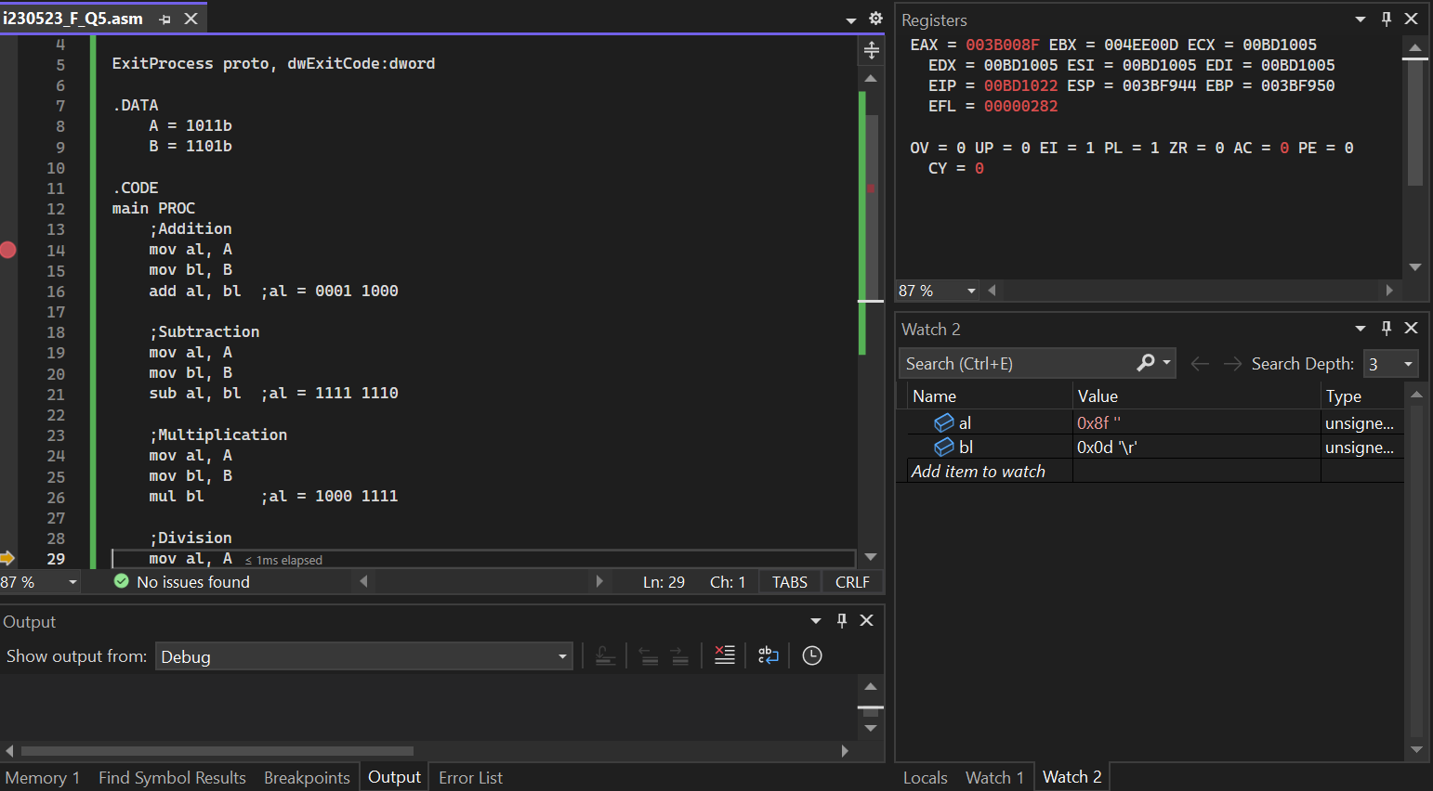
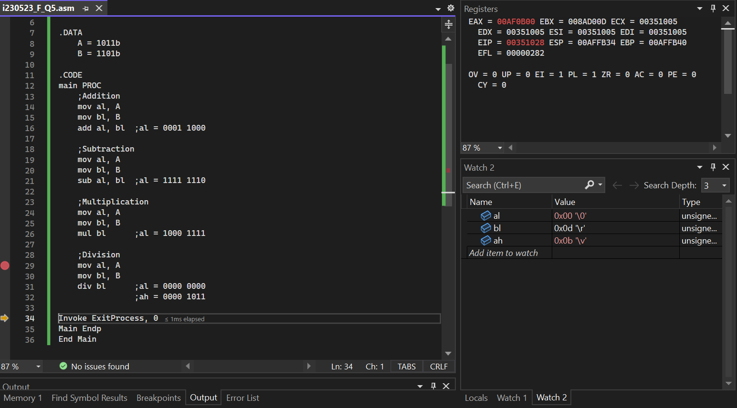

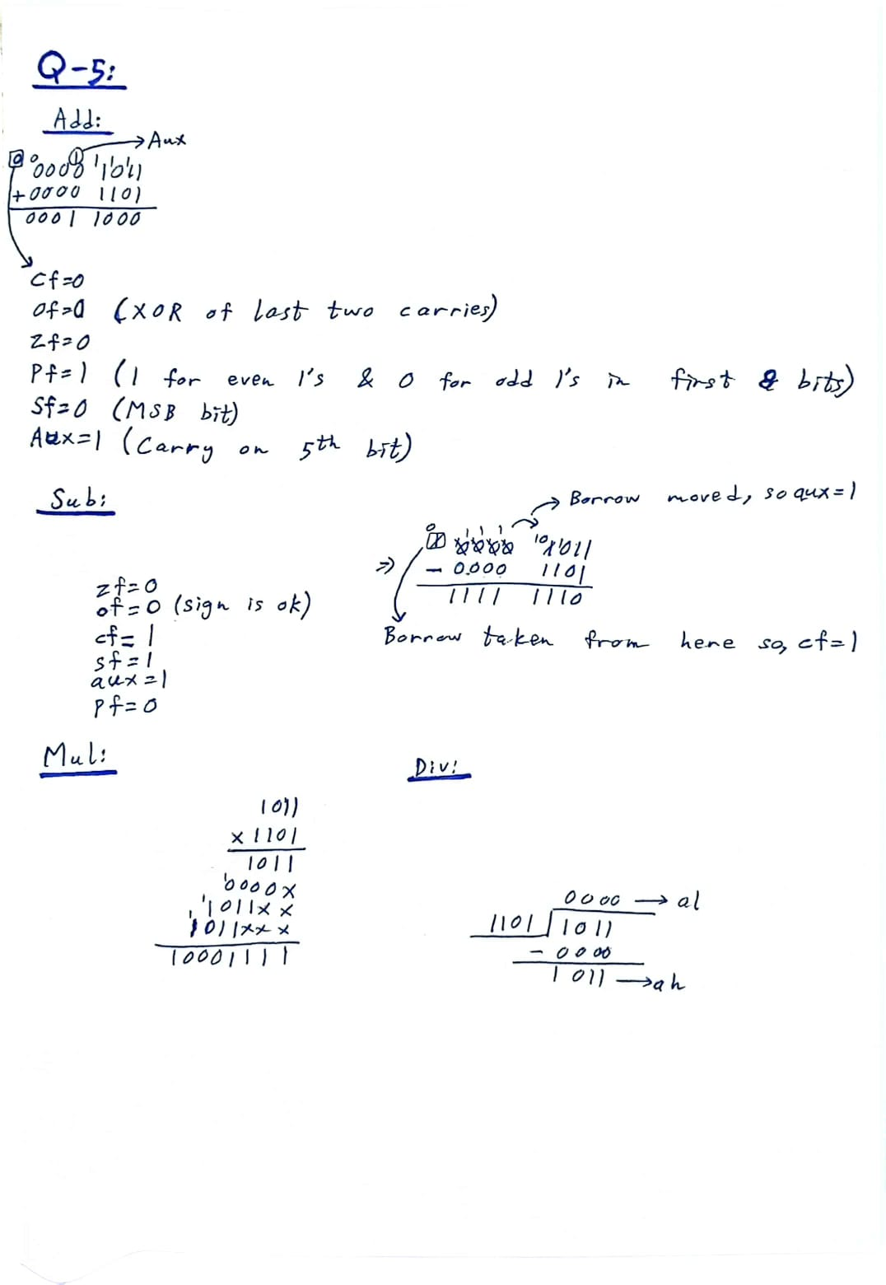
- Take two binary numbers, X = 1110 and Y = 0101. Execute a multiplication, decrement, addition, subtraction, and Increment. Provide the binary result along with flags value. Explain flags is set.
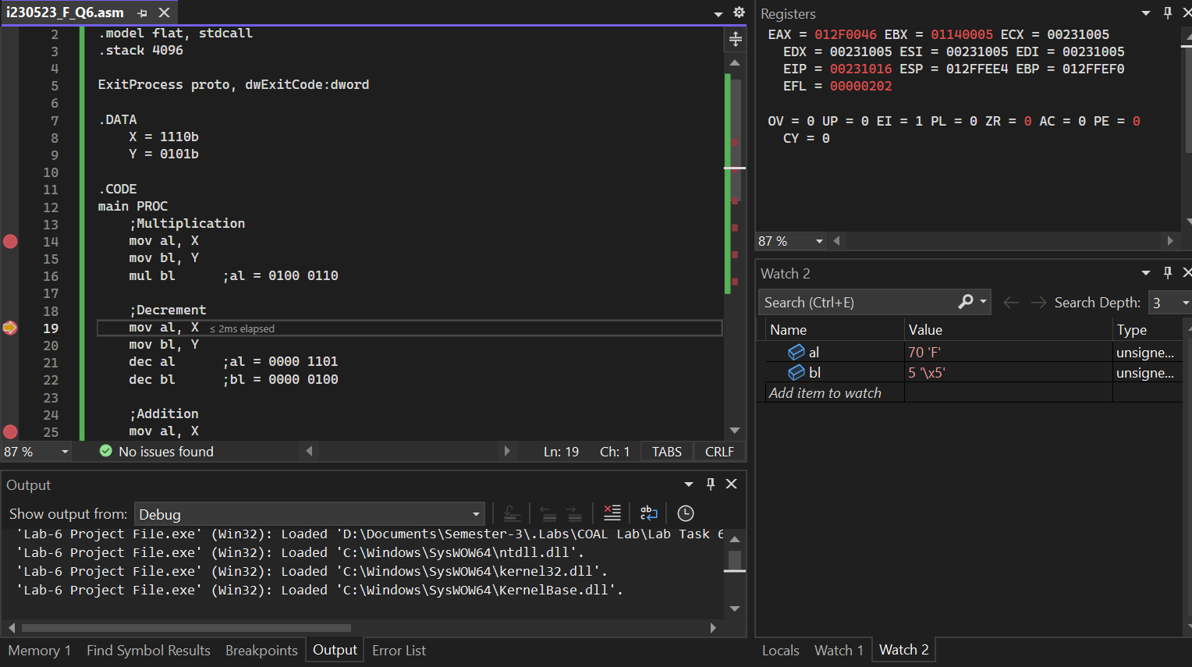
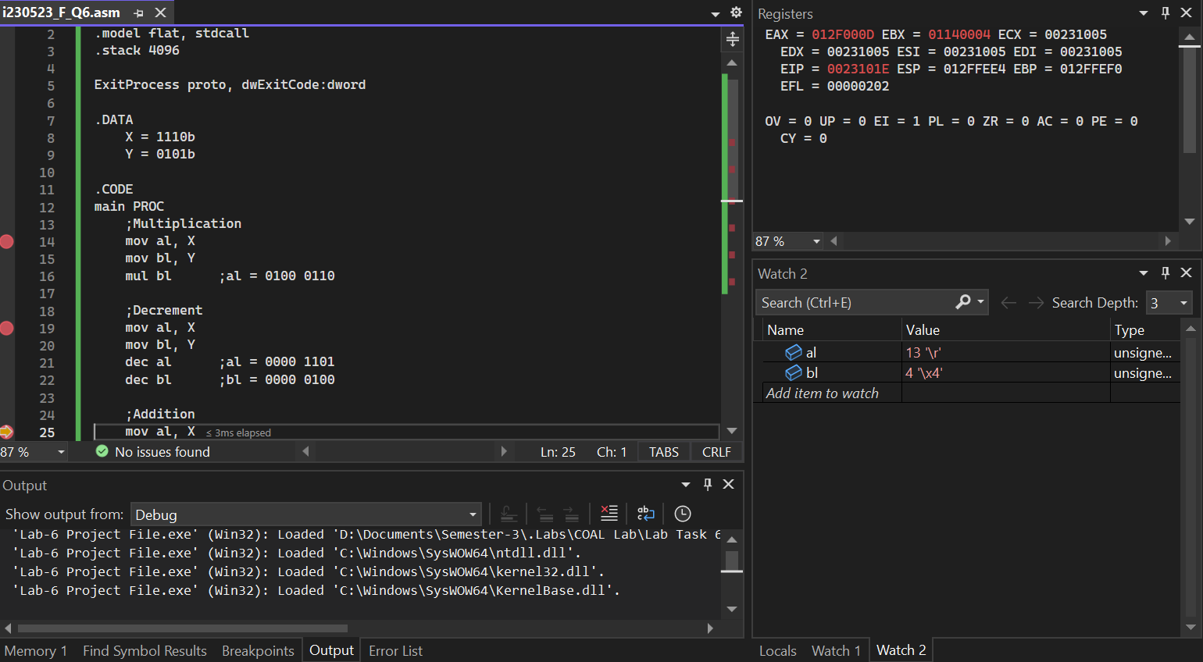
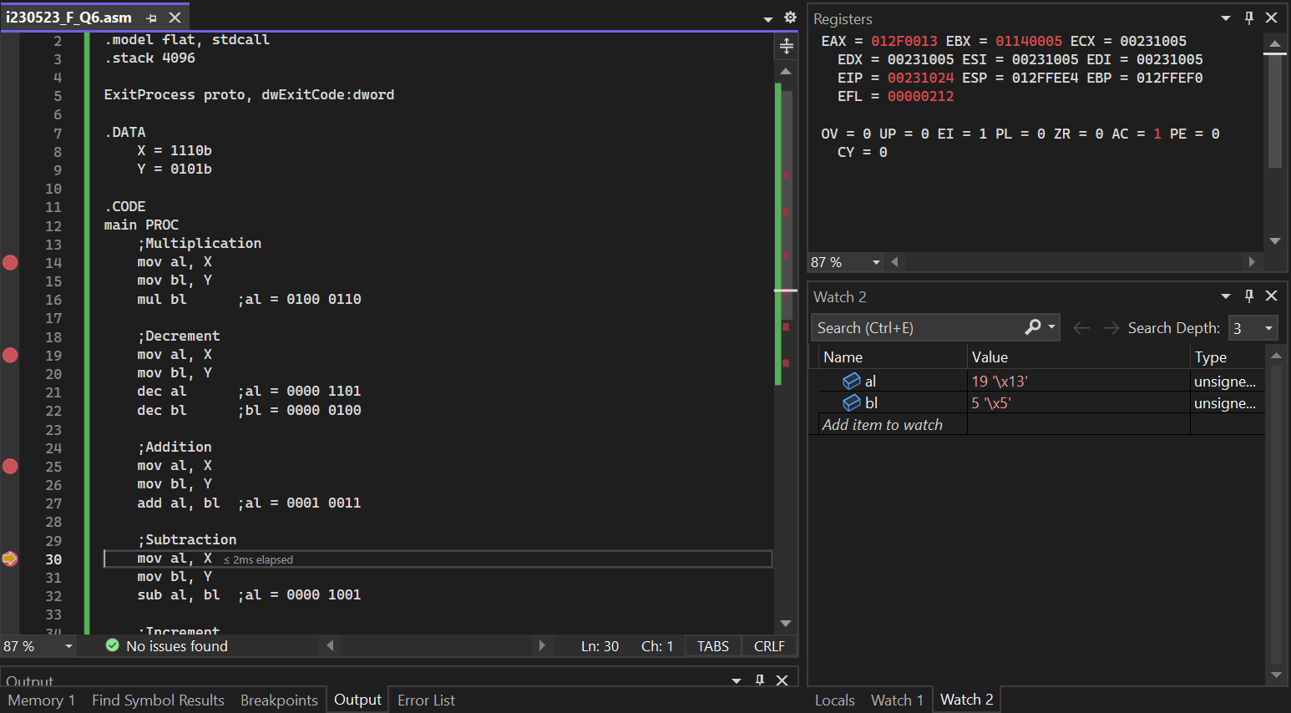
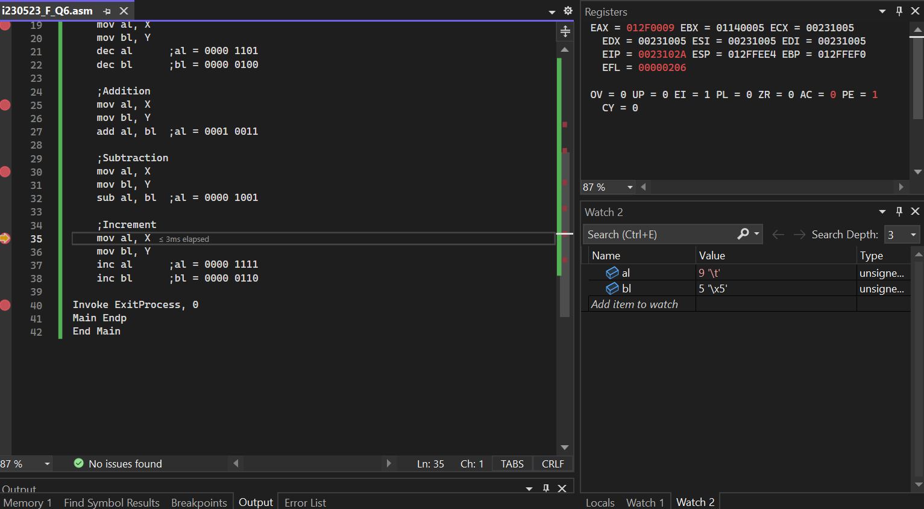
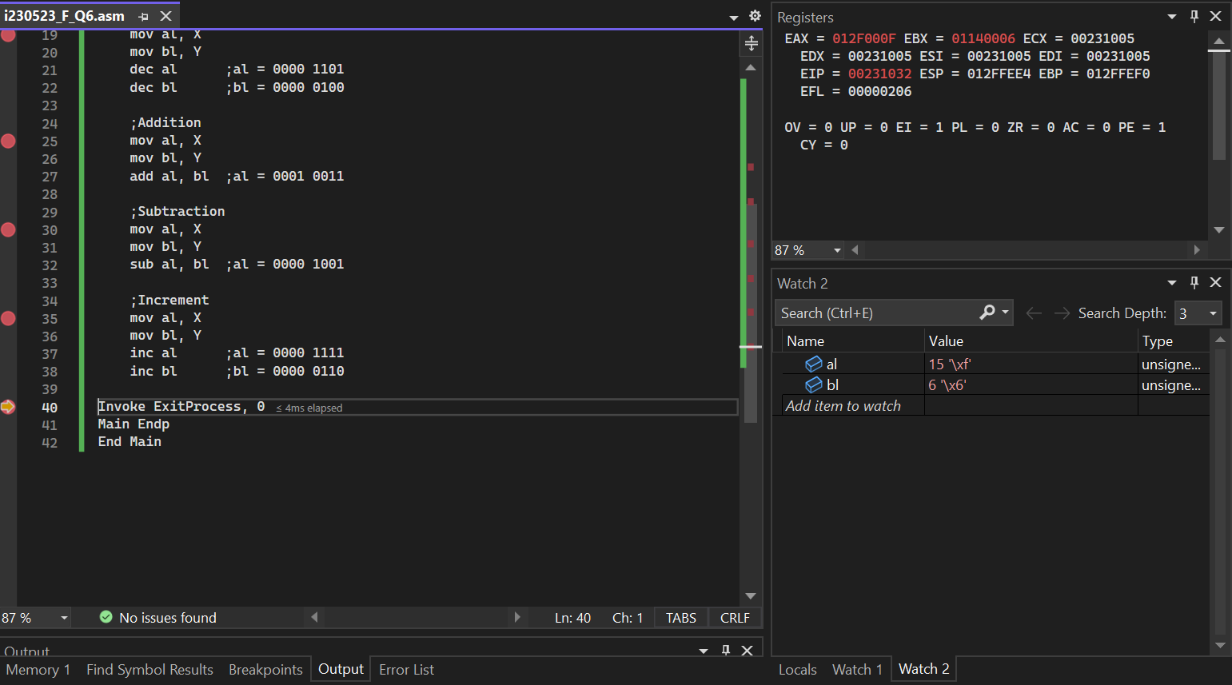
Same rules for will be applied as I mentioned in before Question

- Let's work with the binary numbers R = 1001 and S = 0010. Perform division, increment and decrement operation using the DIV, INC, DEC instruction.
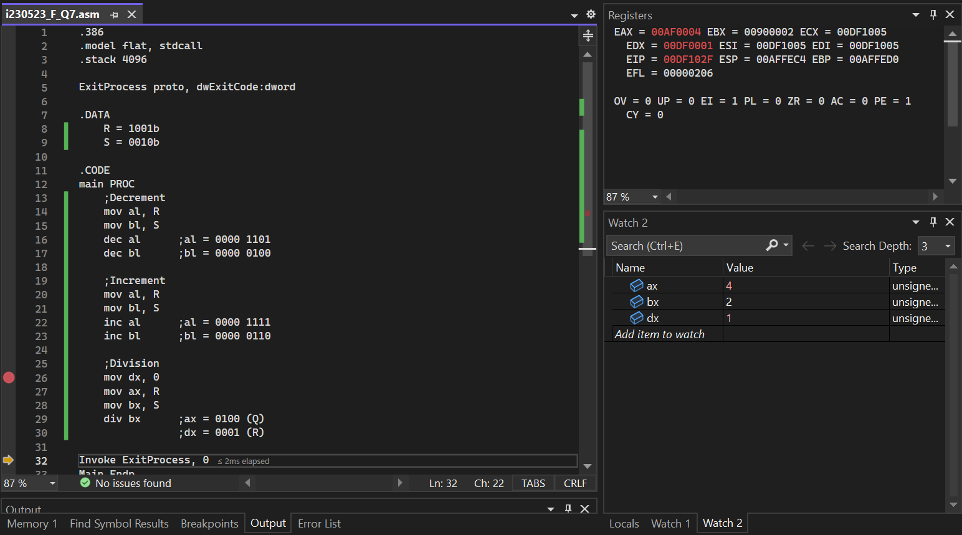
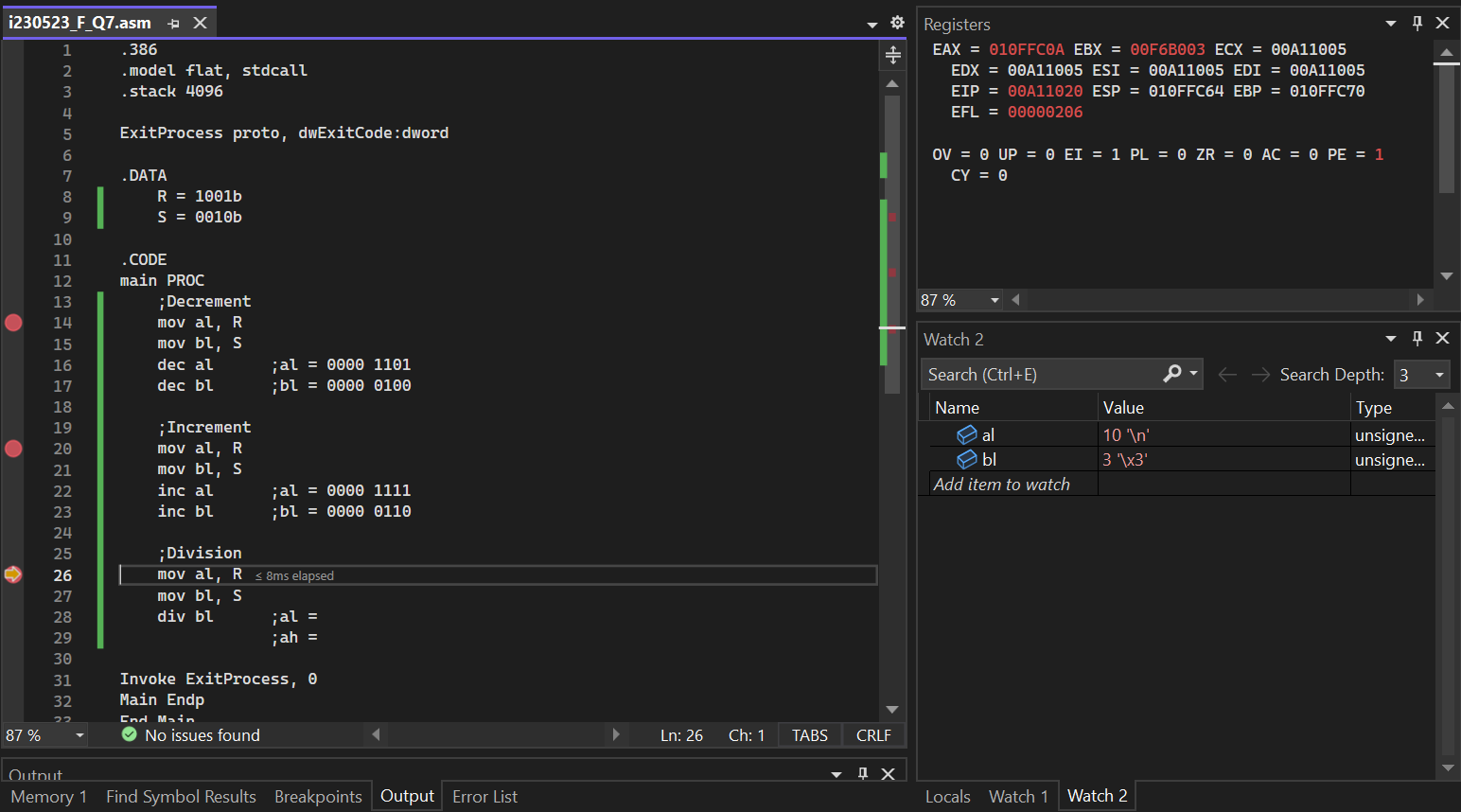
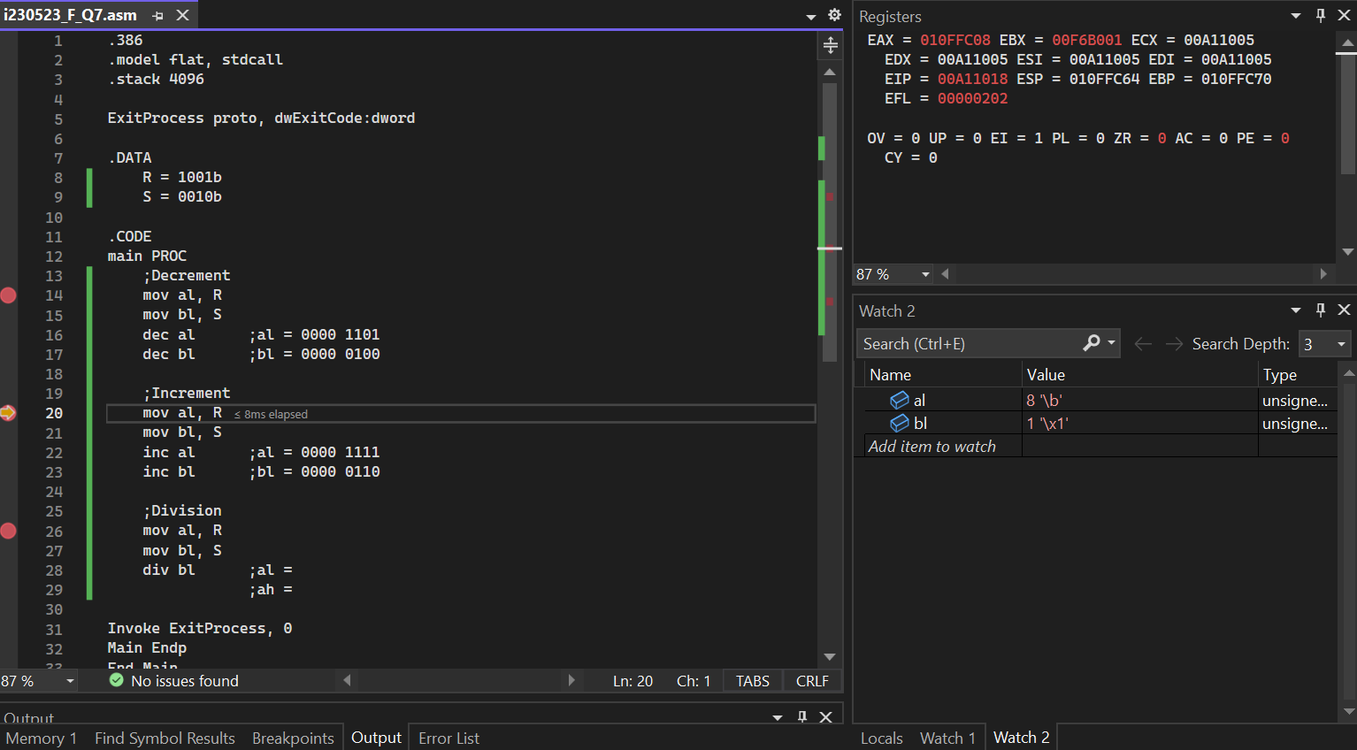

Use loops and labels to complete the following questions.
- Write a code to of generate even number from 1 to (the sum of last 2 digits) of your roll number save it in array.
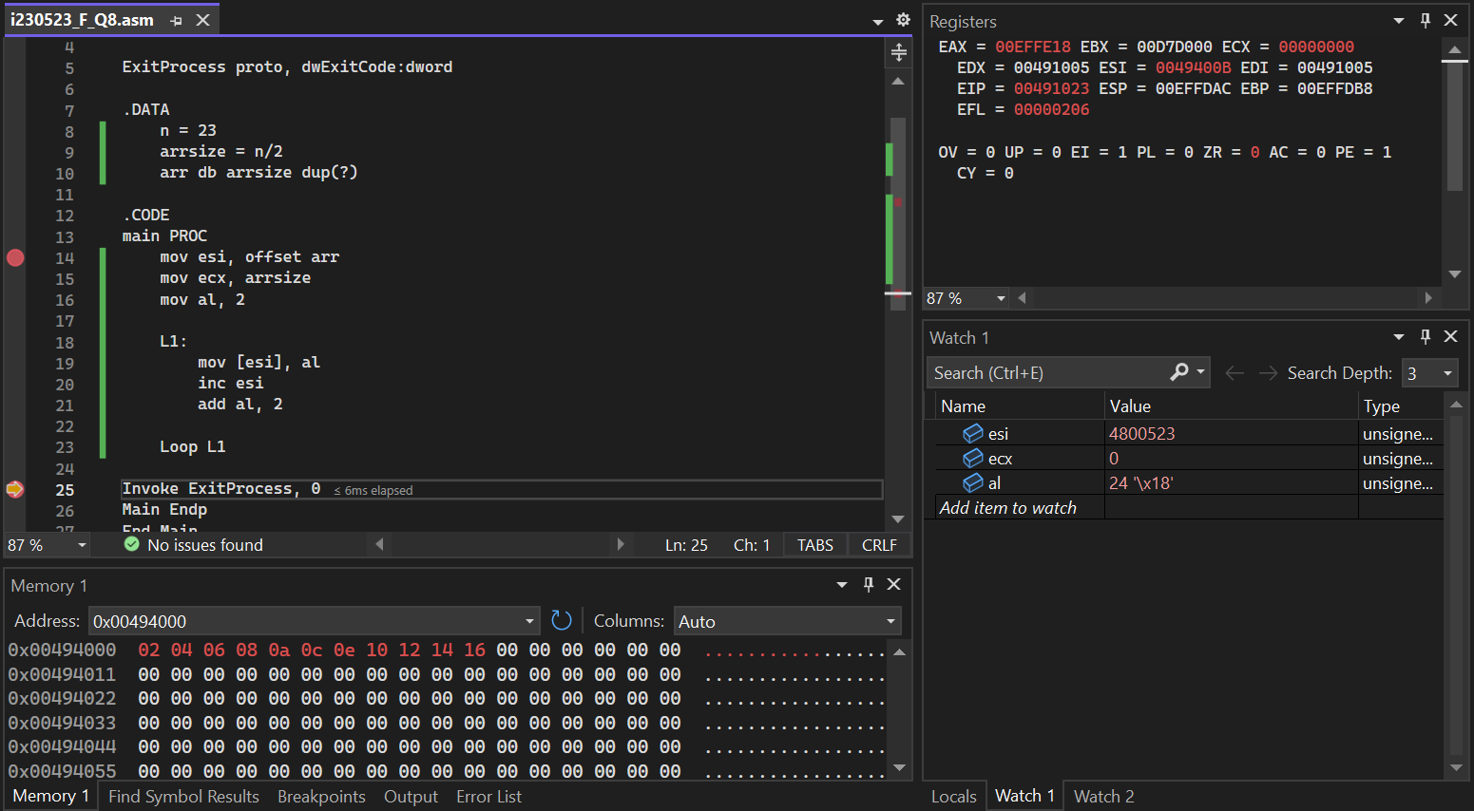
- Find the factorial of last digit of your roll number using loops.
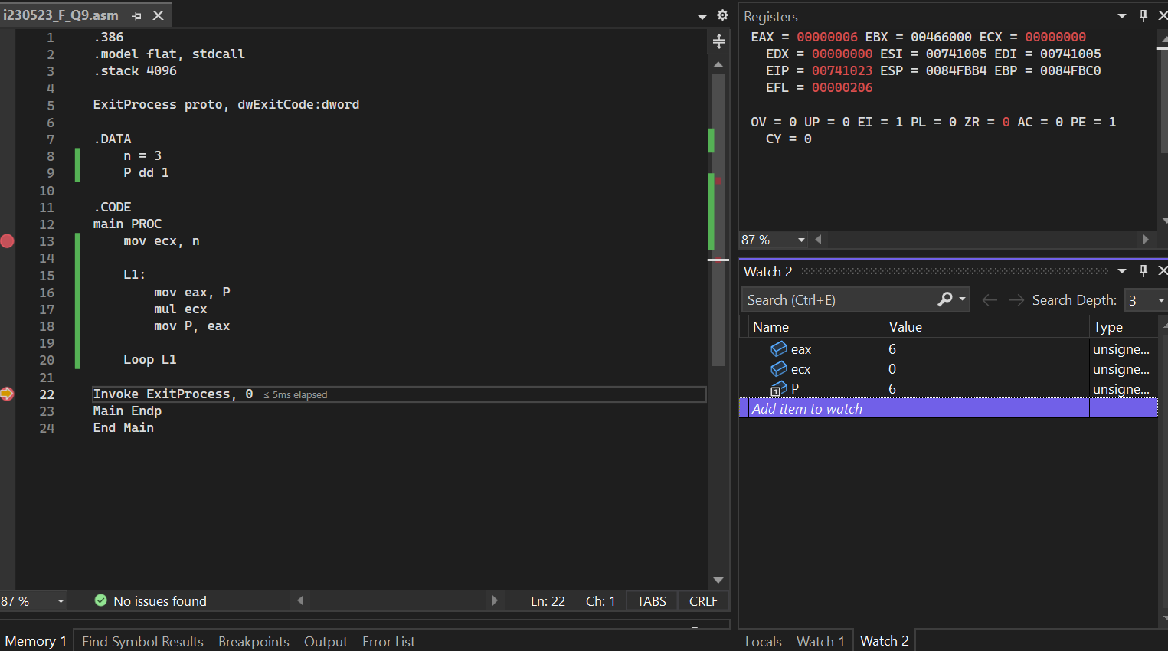
- Show the ASCII code of character a-z using loops.
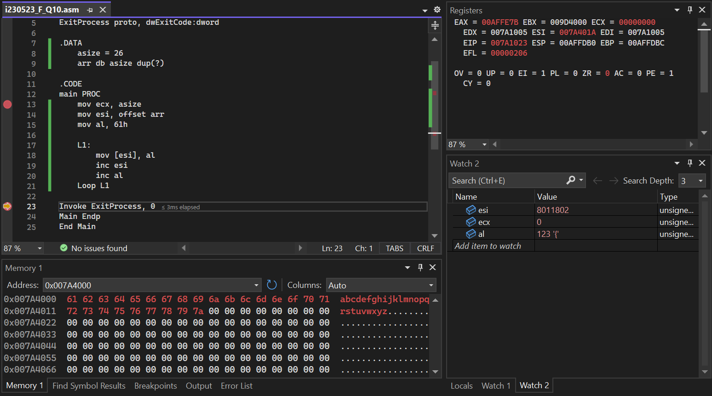

Submission Instruction

Paste the screenshot below each task in the word file.
Submit the word file (having all the screenshots) and .asm files in a zip folder in GCR’s submission tab.

